Gate Demonstrations at GM Office Adilabad SSA
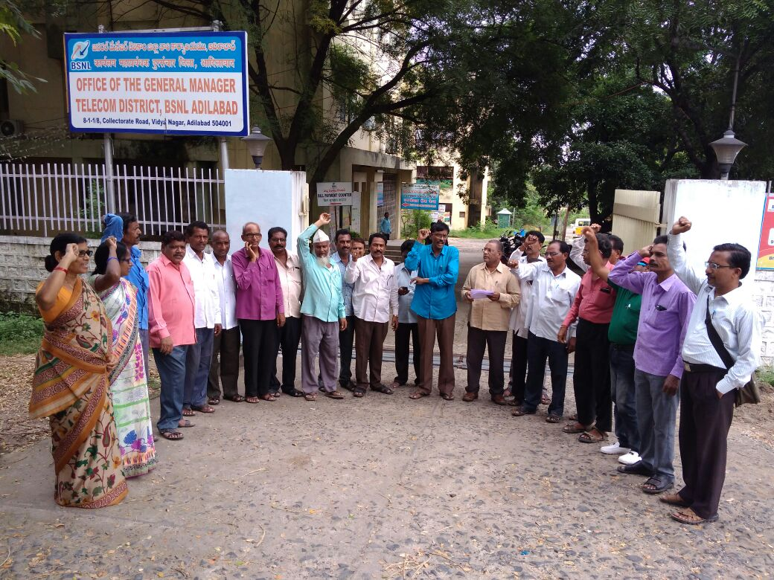

Gate Demonstrations at GM Office Nizamabad SSA
